AI or not AI?

Computers play chess better than humans, and play other games much better than people. This is because there is a limited set of moves and the computer can check these much better than a person can.

Therefore we have to use clever methods to tell humans and computers apart.

We want to stop computers writing adverts on forums. To check if someone is a computer we use Captcha because humans can read distorted texts while machines cannot.

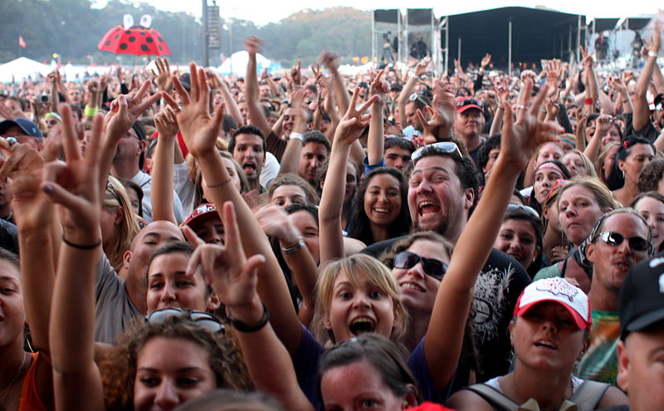

Figure 1: People are much better at making judgements than computers. [1]

Task 1: The power of people

If you ask a computer what is the best café near to the School it cannot answer. This is because it involves a judgement.

1.1

Why don’t computers write the reviews on Travel websites?

1.2

We cannot log in to Wikipedia at school to make changes to it. Why not?

1.3 false information and unsuitable content

How do Wikipedia prevent unsuitable material from being on their site (for example incorrect facts?)

1.4 Why?

Have you ever contributed to Wikipedia?

If you have, what was it and why did you contribute? How do you know the information is correct?

If you did not, explain why not. How do you know information on Wikipedia is correct?

1.5e

Before moving to task 2 make sure that all your questions are answered in full sentences.

How do you feel about crowdsourcing? Do you think that computers will ever be powerful enough to mean that people do not need to do this type of work?



Figure 2: Dr Cut-and-Paste[2]

The BBC reported in 2013 that a German politician needed to resign over copying work for her degree.

One politician who had been caught copying other people’s work for his doctorate became known as Dr Cut-and-Paste.

**It did not seem to matter how many years ago the person had copied some work; the action of plagiarism is still illegal.**

Task 2:

2.1

Why is it wrong to copy and paste information from the Internet?

Universities have an Algorithm to check people who just copy and paste parts of their application for university from the Internet.

These are plagiarism checkers and can be used to check work. Copy and paste plagiarism is easy to check, but there are checks that can monitor writing style and the similarity of the words you use.

2.2

What do you think happens to university students who copy and paste?

2.3

Does it matter if the student does not copy and paste information from the Internet, but writes in their own words?

2.4

Students have been caught copying and pasting homework from Wikipedia. Why is this a problem?

2.5 Copyright Infringement:

Is copying from the Internet legal?

2.6

Is it wrong?

2.7

Does it matter if you copy information from the Internet, but don’t get caught?

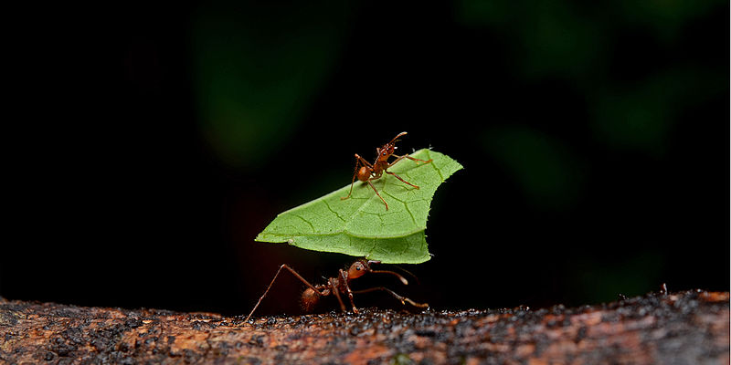

Figure 3: Ants display examples emergent behaviour[3]

Task 3:

Animals can display emergent behaviour. This is where each animal displays behaviour that is simple by itself, but in **combination** they display a complex behaviour

We are going to model emergent behaviour in Scratch

**The rules:**

**Be close** (move towards the group)

**Direction** (move in the same direction as the group)

**Avoid crowding** (move away from close neighbours)

3.1 Cat name

Call the cat UserCat

3.1 cat move left

Create a new program in Scratch. Make the cat move to the right using the code below:

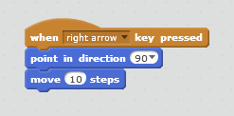

3.2 cat move right

Similarly to 3.1, make the cat move to the left.

You will need to change the direction that the cat faces in.

3.3 Add two new cats

Add two new cats to the stage. Call one CatOne, and one CatTwo

3.4 Move to the average position of the other two cats

The code below goes into the script for CatOne

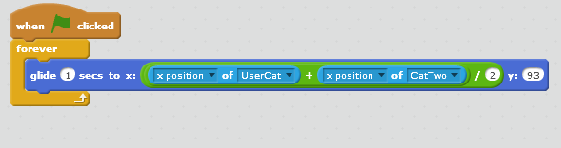

3.4 Add the following code to CatOne

We need to make the cat move away from the UserCat when it reaches it (after all, flocking birds do not crash into each other). Add the following under the glide in CatOne.

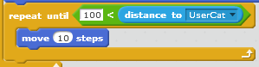

3.5 Add similar code into CatTwo

The following code goes into CatTwo:

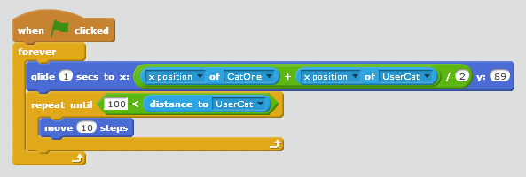

3.6:To complete the model

* Make the UserCat move up and down according to key presses up and down
* Make CatOne and CatTwo follow UserCat up and down (y position)
* Make sure that your model follows the rules of flocking

Task 4:

4.1

Do you think computers can use a set of very simple instructions (like emergent behaviour in Task 3) to check Wikipedia articles?

If not, why not?

1. <https://commons.wikimedia.org/wiki/File:Flickr_-_moses_namkung_-_The_Crowd_For_DMB_1.jpgl> Moses
2. <https://de.wikipedia.org/wiki/Annette_Schavan#/media/File:Annette_Schavan_Portrait_2013.jpg>; Annette Schavan, MdB (2013)
3. <https://commons.wikimedia.org/wiki/File:Leafcutter_ants.jpg>; Geoff Gallice from Gainesville, FL, USA